The following is a transcription of the original documents transcribed as written. They state the purpose establishing the church, baptisms, deaths and other church information. Pages were written from front to back and upside down back to front. The picture of the page is a copy of one of the original pages from the record book.

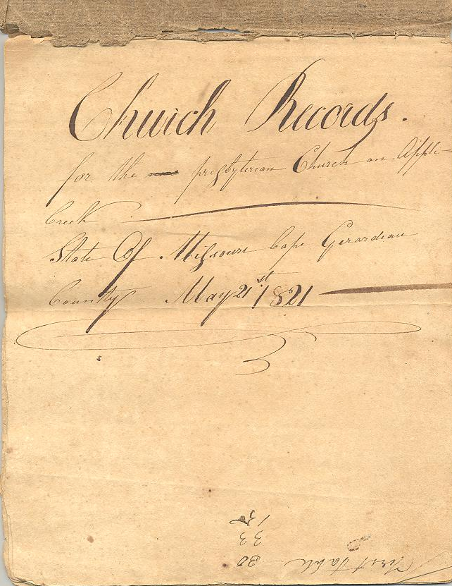

Page 1
May 21st 1820
The Rev. Salmon Giddings met the …sons above named and assembled? To their request proceeded to organize them into a Church of Christ. Voted by said church that Brother Mitchell Fleming, Oliver Harris and John Gilleland & Samuel Anderson shall be the Elders of this church. Ordination was conferred on the same by Mr. Giddings.
March the 4th 1821
Ebenazar Flin and James Hope are Ordain. And Elders of the same Session (by the Rev. Edward Hollister)
*************************************************************************************
Pages 2 & 3

Number of Communicants
Women Mens Names
Mary Brown John Gilleland
Margaret Abernathy John Little
Jean Gilleland Mitchel Fleming
Dorey Gilleland Saml Anderson Dect
Sedy Fleming Oliver Harris
Agness McFarlane Cyrus Henderson
Isabela Henderson Wm Walis
Jean Stephenson George Fleming
Jean Little John Brown
Sarah Wallace Benjamin Brown
Martha Brown Jacob McFarlane
Elizabeth Little Mathew Smith
Jean McFarlane James Wallis
Mary Jetun Elijah Harris
Naomi Brown Milton Harris
Elizabeth Byrd Kiah P. Harris
Jean Anderson Hiram Fleming
Patsy Thompson James Hope
Mary Gilleland Ebenazar Flin
Margaret Harris James Stephenson
Ruby? Wilson William Wallis, Jur
Delia Harris ???? Jetun
Elizabeth Bean or Brown? William Johnson
Patty Hope James Walis?
Margaret Flin May the 8th(?) 1825
Polly Flin Edwin Henderson
Mr. Miller John Little & ???
Mrs. MCLain Alex Little
Hannah Harris Wm A. Hope
Sophina Harris Mathew Henderson
Margaret Smith Moses S. Harris
Jean Wallace Phillip Clotfelter
Burnice Harris ???? Miller
B??t//g Gilleland David Lucky 75
Isabela Johnson March the 6th, 1826
Mary Steel Sacrament of the Lord’s
John Little (Jr or Sr) Supper on the 8th June
Alex Little
young communicates? R???
1825 May the 8th Wilson Gilleland
Narcissa S. Harris Franklin Wallace
Nancy Little Zenas N. Ross
Peggy Little Polly Wallace
Isabela Henderson Lucinda Hope
Jemima Clotfelter

Those on examination
Mrs. Miller
Eleanor Lucky
Mrs. Jean ??????

Number of Communicants
Womens
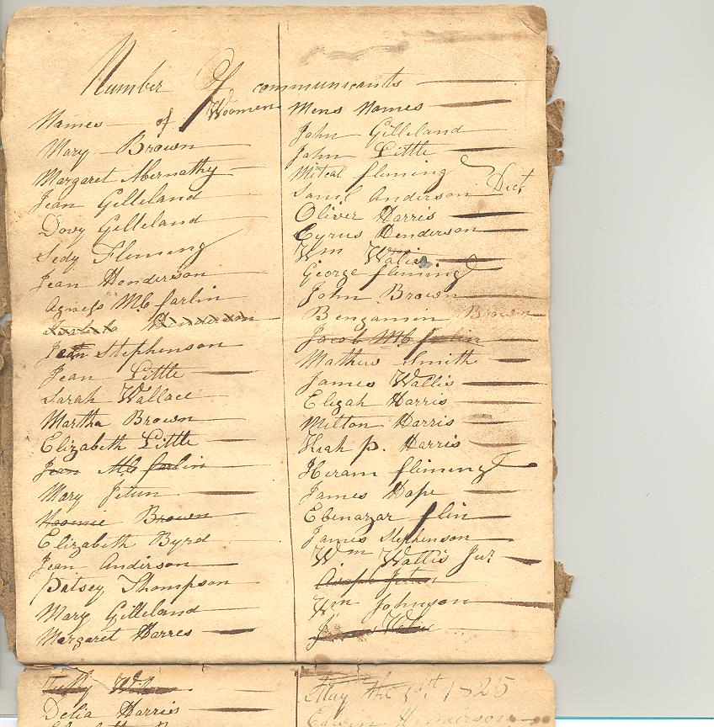
Page 4 & 5
Records of the Church on Apple Creek
Being desirous of enjoying the benefit of the ordinancy of religion which God has instituted and the order to maintain Divine and Public worship live more to his glory and promote each others growth in grace and spiritual comfort, We the undersigned mutually unite together in church relation and covenant known by the Presbyterian Church of Christ on Apple Cree. We also promise as God shall give us grace to watch over each other in the Lord; to conduct in the spirit of Christian meekness; to walk as becometh saints before the world; to maintain the worship of God in our families; and to attend to all the ordinances and means of grace which God hath appointed to be observed in his church. We take the scriptures of the Old and New Testament for the rule of our faith and practices and the confession of faith and Directory as revised and adopted by Presbyterian Churches in America as the best summary and explanation thereof.
*********************************************************************************
Page 6
Jan 22, 1826 Baptized a child for Mr James Wallace
April 16, 1826 Baptized a child for Mr. Milton Harris and wife
April 30, 1826 Baptized a child for Mr Philip Clodfelter and wife
May 13, 1826 Baptized a child for Mr John Prim and wife
October 14 1826 Baptized a child for Mr Mathew Henderson and wife
December 17, 1826 Baptized a child for Mr Elam Adams and wife
****************************************************
Page 7
Six vacant seats vacant
No. 4 taken by John Prim balance is vacant
No. 7 Abner Hope
No. 9 & 10 John Harris
No. 14
No 21 on an accurate calculation of the subscription this is surplus of ??
************************************************************
Page 8
Division of seats in Applecreek meeting house
John Gilliland and William Wallace No. 11
John Harris Alex and Wm McLeans No 18
John Little John Luckey No. 16
Elijah Harris Oliver Harris No. 2
Thomas Wilson Benjamin Brown Philip Clodfelter No. 1
James Hope Elam Adams M McNeely No 13
Joseph Abernathy James Wallace No 12
John Brown John McComb No 20
John Oliver Mitchel Fleming Z Ross George Fleming part vacant No 14
John Adams John McNeely No 7
To pay 50 cents ea No 5
Levi Russell James Stevenson No 23
James Thompson Lot Abernathy Michael Mathews No 10
Abner Hope himself No. 8
Joseph McLean Mary Steel B Wallace No. 19
James Hope ???? Henderson No 28
???? M Henderson W Doherty No 6
Cyrus Henderson his father Mathew Smith No 22
John Wallace his father Royal Thompson No 7
E Flinn Absm ?????? No 3
Milton Harris L Harris Cyrus Harris No 15
John Prim Thomas Harris Part vacant No 4
Vacant part of No 4 filled by Wm Hope
October 26 1826 this is to certify that
Lott Abernathy No 10 given up to James Thompson
part vacant to be taken by Mahala Mathews
George Fleming part vacant No 14
John Adams John McNeely No 7
To pay 50 cents each
Vacant 7,9,14
*****************************************************************************
Page 9
Record of removals
Jacob McFarlin
Jeane McFarlin
****************************************************************************
Page 10 Baptisms
Milton Harris children; Sarah, Amelia
Matthew Smith: James Wallace
Edward Harris: Robert Washington
Zenos Ross: Margaret Harriet
Ben Brown: Michael Alexander
Levi Torrence: Barbara Ann
Philip Clodfelter: David Foster
William Johnson of Perry County two children
March 28 1830
Committed to baptism
Levy N Torrence children
Milton Harris one Mary Adalaide
Levi Torrence: Nancy Jemima
George Fleming one Narcissa Jane
James Little one John Michael
Robert McFarland three Elizabeth Sady, Margaret Rosanna, Rebecca
Joseph McNeely one
*************************************************************
Page 11 Record for Deaths
1821) Agnes Fleming Aug 21 {She is buried in the Fleming Cem with her husband and daughter sic}
James Harris
1822) Robert Steel May the 10th
Margaret Fleming Aug 14th
1823) Naomi Brown Sept the 5th
Charles Wallace Oct the 30th
Ruthy Wallace November the 17th
Samuel Anderson Dec
(1824) Mr. Hart
Andrew J Steel
Charles Harris
Mrs. Price
Susannah Abernathy
Gibony 1824
Ephraim Harris
June) John Gilliland
March 26 1829 Cyrenius Flinn
1830 John Harris March 1st
********************************************************
Page 12 Record for Marriages
1824) Joseph McLain & Jean Gilliland
Robert McFarlin and Agnes Fleming
1822) Royal Thompson and Jean Wallace
Benjamin Brown and Mary Fleming
James R Little and Betsy Fleming
Sep the 20th 1823- Jan 15 1824
James Russell and Betsey Gilliland
James Wallace and Polly Abernathy
Mitchell Fleming and Jean Stephenson
William B Wallace and Dovey G Hope
October 21st Anderson Bull and Rachel Wallace
Oct 28the John Wallace and Betsy Abernathy
1825 Thomas Harris and Bernice Harris
**********************************************
Page 13 Record of Births and Baptisms 1824
Phillip Clodfelter child Elizabeth Leonard
Joseph McLain 2 John and Dovey Ann
William Harris 2 Robert B and John G
David Lucky 1 Elizabeth Jean
Matthew Smith 1 Elizabeth Mary
Benjamin Brown 1 Martha Ann
Harris Little 1 Nancy Jean
James Wallace 1 Glaphira Caroline
March the 6th 1826
**********************************************
Page 14 Record for Births and Baptisms
1824) Polly L Henderson
William D Harris
Jean Almira Smith
Leah Lavira Smith
Wm L Smith (Mr. Sprague)
1822)
Forgey Miller 2 children baptized
William Wallis 1 child baptized
James Stephenson 1 child baptized
Nov. 16th 1823 John Franklin Little baptized
John Decalogs Abernathy baptized
Aug the 8th 1824
Mary Jean Johnson
Joseph Abner Hope
Abner Wallace
John Leander Brown
Dec 31 –Jan 1 1825
Nancy Caroline Stephenson
Margaret Jean Henderson
Nancy Jean McFarlin
******************************************
Page 15 Church Records
For the Presbyterian Church on Apple Creek
State of Missouri Cape Girardeau County May 21st 1821
On the bottom of the page written upside down was ?? table 30, 33, 15
******************************************************

Page 16
Also on the sacramental qualifications stated there were added to the congregation the following members they being the result of late emigrations
Levi Russell and wife
Cyrus Alexander and wife
Margaret Harris
Lilly Henderson
Joseph Stanhope Cochran
Zenas N Ross
The above eight persons all admitted and joined this church on certificate also at the same time and place
Robert Brevard and wife
Meridith and wife
Joined and admitted on ???? recommendation
May 1830
Levy Torrence (E
Margaret B Torrence (C
Newton Query (C
John N Adams (C
Martha A Adams (C
Rebecca Prim (E
Ann Woods (E
Robert McFarland (E
Ambrose Alexander (C
Eleanor Alexander (C
Narcissa Alexander (C
Alexander L Alexander (C
James Woods & wife (C
??? McCombs (E
Robert A Alexander (C

1830-1839

“The book containing the session minutes of Apple Creek Church was burned with the pastor’s house
and library on Feb. 6, 1833. The pastor was the Rev. John F. Cowan.

In the early 1830s began the outcropping of the “Great Cause” which in 1838 caused the division of the Presbyterian Church and in 1860-1865 almost caused the disruption of the nation. The first rumblings of the historic cause were heard in Apple Creek Church when the Rev. J. M. Covington who labored here for one-fourth of his time prior to 1833 charged that the Doctrine of Christian Responsibility was repugnant to many of the members and some of the session.

The dissatisfaction grew during the ministry of Mr. Cowan (1833-1837) until there were two parties in Apple Creek Church. On June 10, 1833, the session resolved that it would be conducive to the peace and good order of our church if the Rev. J. F. Cowan would desist from writing us or intermeddling in our affairs. Mr. Cowan was dismissed as pastor.

Presbytery appointed a commission to attempt to restore harmony. The effort of the commission was not successful and the church was divided. About half of the congregation became the North Apple Creek church and the others the South Apple Creek Church. The record gives a long attempt of the two groups to arrive at a settlement of which one would become the owner of the property and offers of payment by one group to the other. There is no record of any of the minutes of the final settlement.”
(Biography of Historic Cape Girardeau County, Articles collected by Jess E. Thelinius, second printing)

